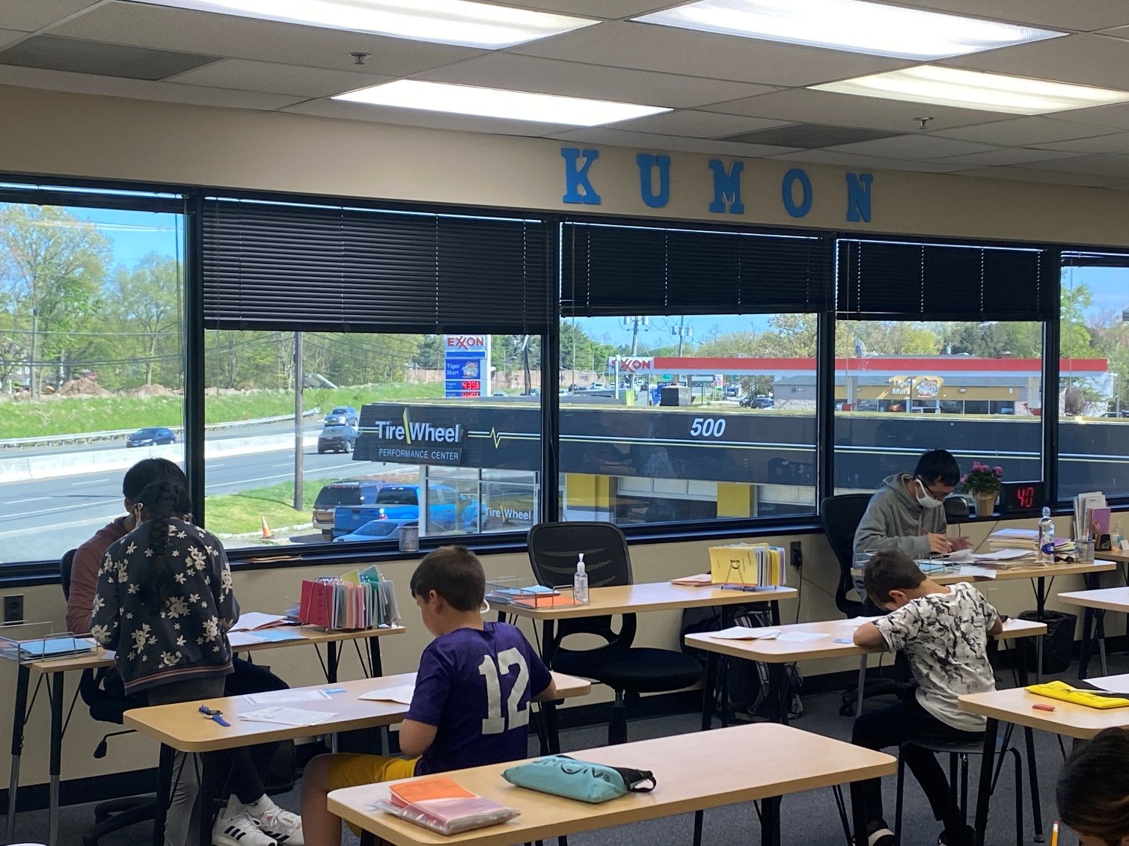
OBJECT AK Exhibit -5
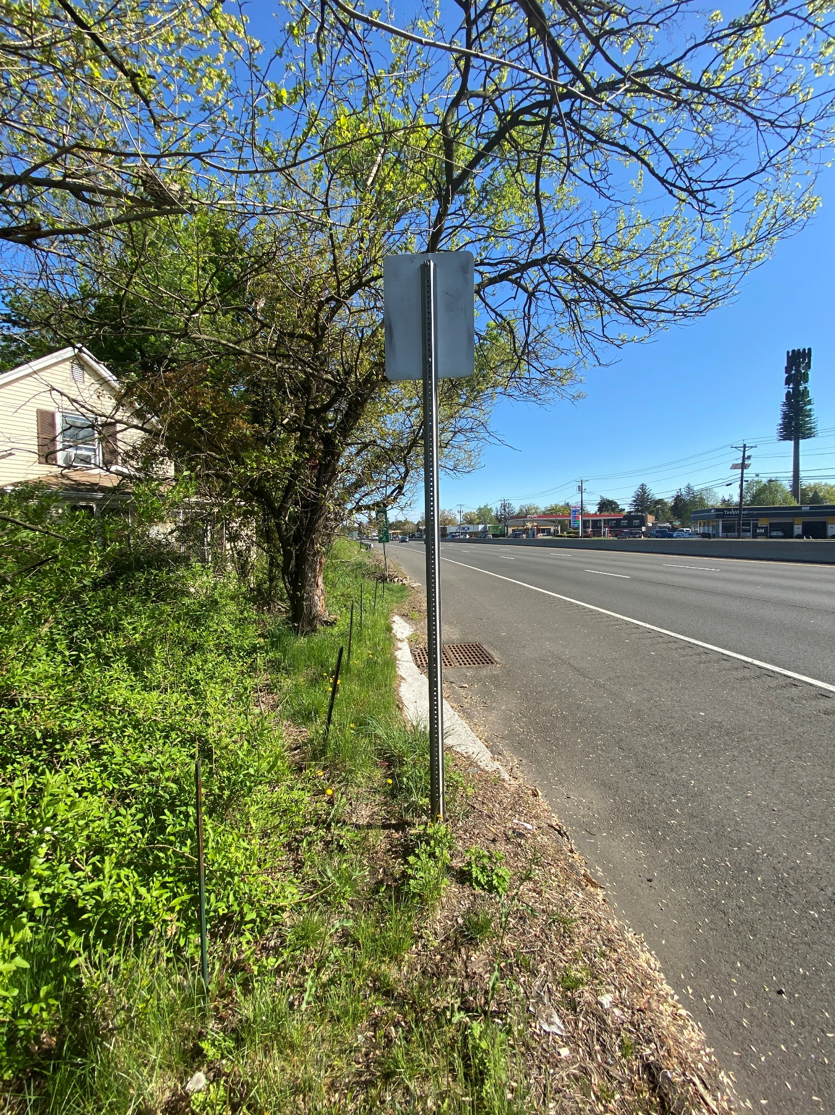
OBJECT AK Exhibit-6

